**Format to report your ADVANCED JAVA PROGRAMMING PROJECTS**

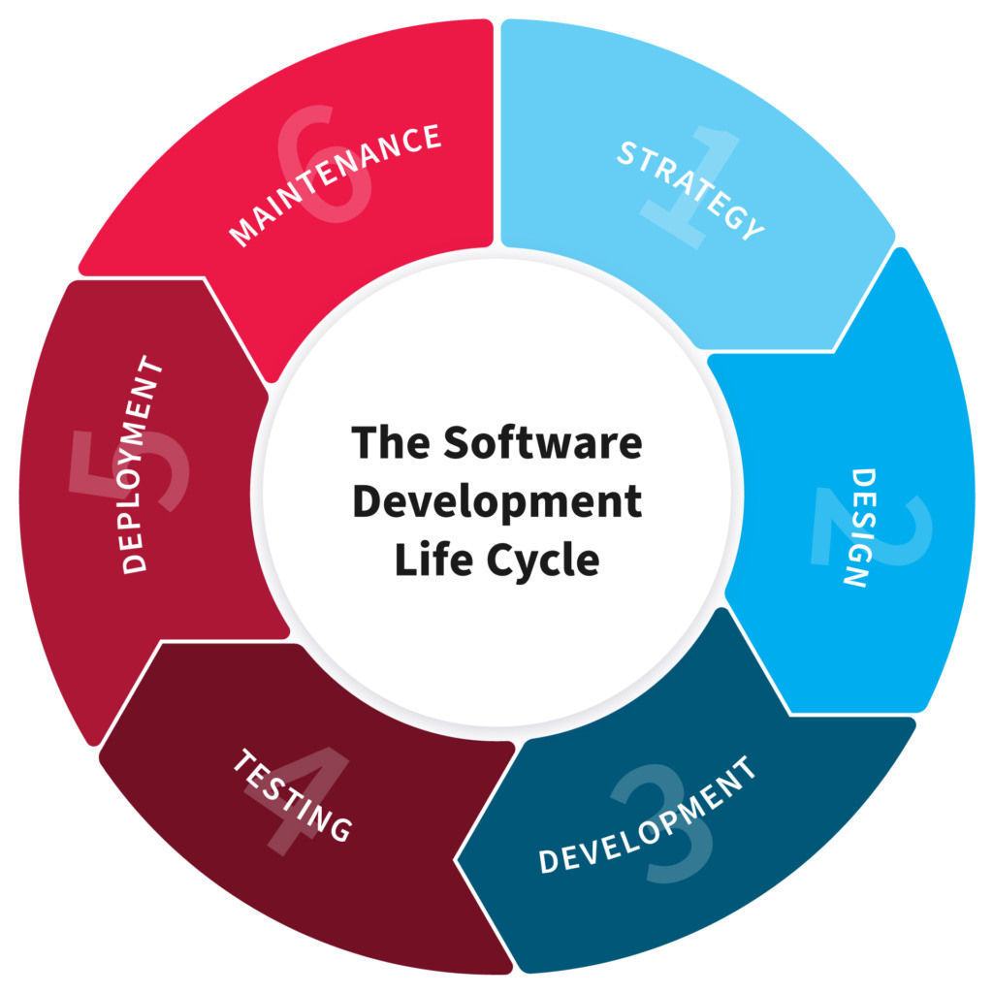

NAME:NYIRANSENGIMANA Antoinette

REG NO: 221013600

CLASS NO: 17

PROJECT NAME: HR MANAGEMENT SYSTEM

**HR MANAGEMENT SYSTEM**:An HRMS, or human resources management system, is a suite of software applications used to manage human resources and related processes throughout the employee lifecycle. An HRMS enables a company to fully understand its workforce while staying compliant with changing tax laws and labor regulations.

1.**Planning**

HR Management system as is an application that is used to manage Human resources (staff) ,HR leaders and staff are the primary users, given that they run day-to-day workforce operations and are responsible for compliance and performance reporting record their works, manage their positions and authorities, and manage their payments by generating their invoices, tracking their overtimes, advances and deductions. This system will help alot in companies employees management and new hires handling.

1. **Design**

Our system is disigned in way that will allow the uses to act their rules such the HR Leader and other employees, to our system the work of manager is an admin work will help human resource manager to coordinate all employees activity and will provide an access to the system to employees,not only but olso will help employees to send same information to the manager such as extra time worked .

Manager(Admins):

Add new employee/ admin/manager

Update users data

Record employee's daily work

Generate employee's invoice(pay slip)

Delete users

Create new login credentials for user

The app allows managers to search through the list of employees when the list is long to manage.

We are planning to make users(employee's) side of the app where they will be able to access the system, view their work status and ratings, record their ovetimes, create their invoices then send to the managers for approval

1. **Development**
2. Here are different tools and technologies we used while developing this app

IDE

- We have used Netbeans to develop this project

Frontend

We have used Java swing to design and develop the frontend part of this project

Backend

On the backend part of this app we have used core java integrated with java swing to connect BE and FE

Database

The database used in this project is MySQL and we have used JDBS to connect to my sql in our local computer (via xamp/ or manual installation of mySQL)

We have also used MySQL connector jar to connect to the Database.

1. **Testing**

Testing this app, we have tested it manually, no written tests or automated test but within a group of 5 people we tested for each edge case and made sure that the app worked like we expected. While testing we also discovered things that needs to be changed and we planned to work on that and adding new features as well.

1. **Deployment**

We didn't deploy this app to the outside world, we have pushed our code to github for us to collaborate. But we have learned different ways of deploying a java application and we are willing to deploy it anytime it may be needed and our cde give us hope to be good developers.